Agile Group Project

By

Tejbir Singh

Joban Singh

Sukhraj Singh

Harpreet Singh

Harmanpreet Singh

Manpreet Kaur

Contents

Introduction 2

Project Members 3

Agile Methodology 4

Pages and Mock-ups 4

Home 4

Popular Events Page 5

Search Event Page and Search Result Page 6

Free Events Page 7

Free Event Detail Page 8

Paid Events Page 8

Paid Event Detail Page 9

Conclusion 10

# Introduction

The main goal of this project is the design of an agile / scrum mobile application. We have created an application for finding the Events using RestSharp Library. RestSharp is an all-round HTTP client library open-source that deals with DotNet technologies of all kinds. This enables flexible applications to be developed by enabling integration to public APIs and fast access to data without the hassle of dealing with raw HTTP requests. RestSharp blends many benefits with a clean, simple interface, making it one of today's hottest REST devices.

The REST architecture with its easy API and efficient library is the alternative of developers searching for comprehensive applications and programs. RESTful architecture offers a resource-oriented information-driven approach to web application development. It also provides joint tasks as configurable options, such as URI generation, payload parsing, and encryption, to ensure that application developers are no longer concerned with low-level tasks, such as networking.

In this Locate an Event application, a user can search various events around. Also, the events on a particular name. With the help of RestSharp Library users can directly access the information about events from the internet.

# Project Members

To increase the effectiveness of the application, five team members are participating in a different role that is given in the below table:

|  |  |
| --- | --- |
| Name of Team Member | Role |
| Joban Singh | Team Leader |
| Tejbir Singh and Manpreet Kaur | Front End Developer |
| Sukhraj Singh | Application Tester |
| Harpreet Singh | Web Designer |
| Harmandeep Singh | Back End Developer (API) |

All members make their attempts to complete the project and to meet the needs of the client by submitting an application Event Finder

# Agile Methodology

The agile approach is used as an alternative to traditional methods in this project. This strategy is very effective and pragmatic and addresses the changing needs of the technology. It is cost-effective, quick, and delivers ongoing changes.

Our group used the agile / scrum approach here in this project. At the start, the team members define and address all criteria. The team then decided to implement the special feature in the Event Finder application so that it could meet users ' needs.

Several improvements to the application have been made to make it more user-friendly and appealing to the user's suggestion. After all improvements have been introduced and applied, the app is available for use by the consumers.

# Pages and Mock-ups

## Home

This is the main page of the application. On this page there are three buttons Popular, and search. Whenever a user wants to know the popular events around he/she can click on the popular button and need to add location, the application will display all relevant events in that location. The search button helps find free and paid events in the city.

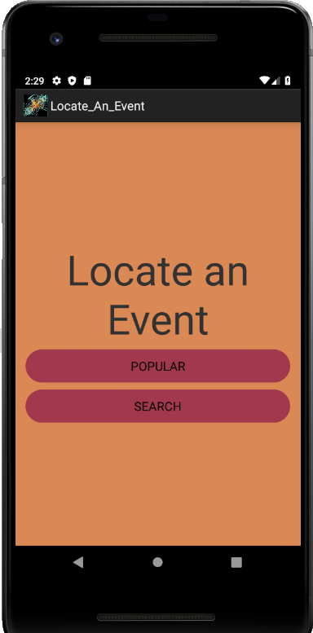

## Popular Events Page

This page will highlight all the popular events within the city.

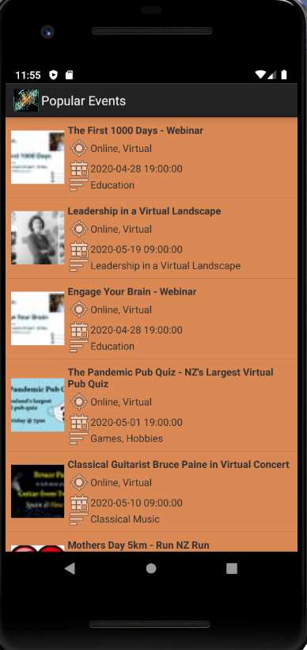 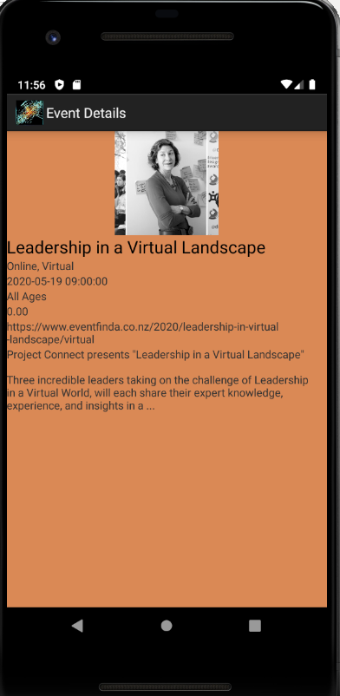

# Search Event Page and Search Result Page

With the help of this page users can search the free as well as paid events by adding the name of their choice.

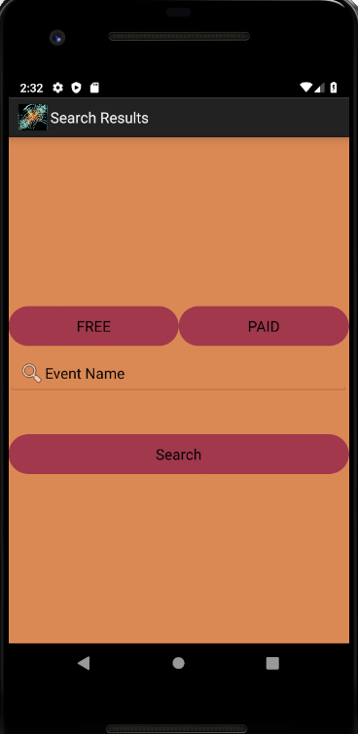

# Free Events Page

While searching for events when users select free events button. The Free Event page displays the free events in that location entered by the user.

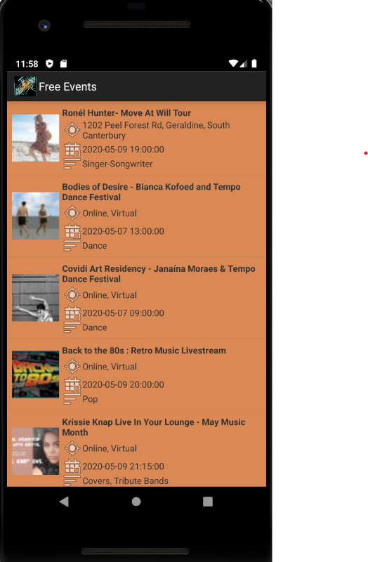

# Free Event Detail Page

If the user wants to access the details of the particular event of his or her choice. User needs to click on the event and the free event detail page will display the details of that event.

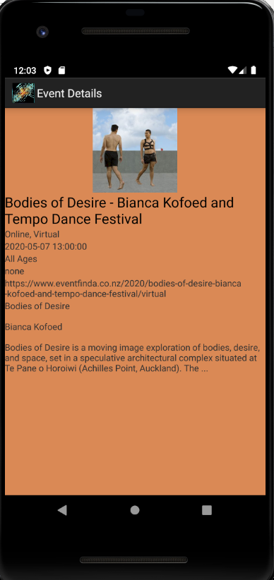

## Paid Events Page

While Searching for the events, if the user selects the paid event based on a particular location, then this app will display the paid event in that location. The Paid Event page will display the information.

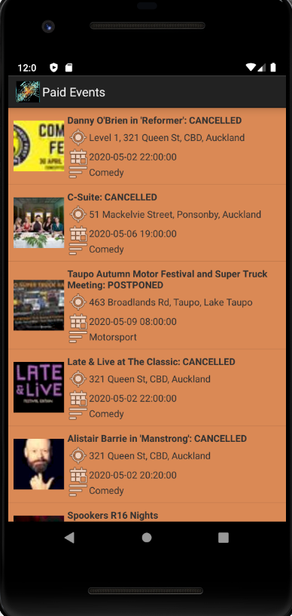

## Paid Event Detail Page

If a user wants to access the details of the particular paid event of his or her choice. User needs to click on the event and the paid event detail page will display the details of that event.

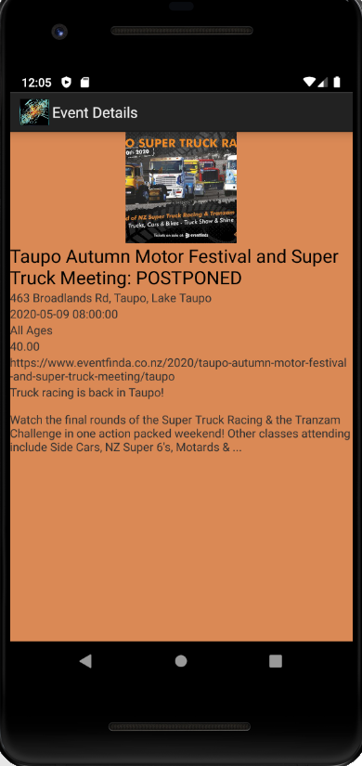

# Conclusion

In brief, this project is based on an agile scrum approach, in which the IT group developed the Android application known as LocateAnEvent.